**جـــــدول الكـــتـلة**

|  |  |  |  |  |  |  |
| --- | --- | --- | --- | --- | --- | --- |
| **mg** | **cg** | **dg** | **g** | **dag** | **hg** | **kg** |
|  |  |  |  |  |  |  |

**جـــــدول الأطوال**

|  |  |  |  |  |  |  |
| --- | --- | --- | --- | --- | --- | --- |
| **mm** | **cm** | **dm** | **m** | **dam** | **hm** | **km** |
|  |  |  |  |  |  |  |

**جـــــدول المراتب**

|  |  |  |  |  |  |
| --- | --- | --- | --- | --- | --- |
| **وحدات بسيطة** | | | **الألاف** | | |
| **الوحدات** | **العشرات** | **المئات** | **الوحدات** | **العشرات** | **المئات** |
|  |  |  |  |  |  |

**جـــــدول قياس السعات**

|  |  |  |  |  |  |  |
| --- | --- | --- | --- | --- | --- | --- |
| **mL** | **cL** | **dL** | **L** | **daL** | **hL** |  |
|  |  |  |  |  |  |  |

**جـــــدول السعات**

|  |  |  |  |
| --- | --- | --- | --- |
| **mL** | **cL** | **dL** | **L** |
|  |  |  | **1** |
|  |  | **0** | **1** |
|  | **0** | **0** | **1** |
| **0** | **0** | **0** | **1** |

**أجزاء المتر**

|  |  |  |  |
| --- | --- | --- | --- |
| **mm** | **cm** | **dm** | **m** |
|  |  |  | **1** |
|  |  | **0** | **1** |
|  | **0** | **0** | **1** |
| **0** | **0** | **0** | **1** |

** مضاعفات المتر**

|  |  |  |  |
| --- | --- | --- | --- |
| **m** | **dam** | **hm** | **km** |
| **0** | **0** | **0** | **1** |
| **0** | **0** | **1** |  |
| **0** | **1** |  |  |
| **1** |  |  |  |
| **وحدات** | **عشرات** | **مئات** | **آلاف** |
|  |  |  |  |



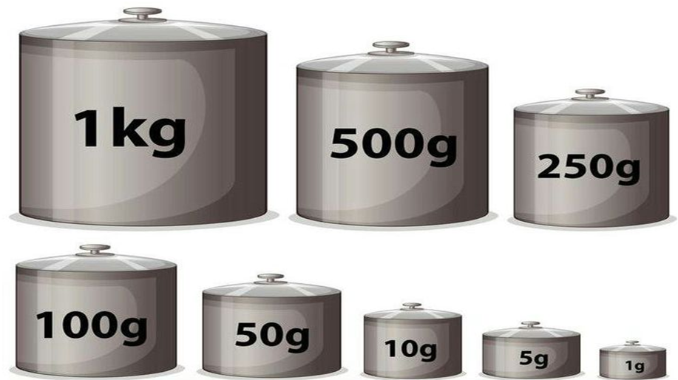

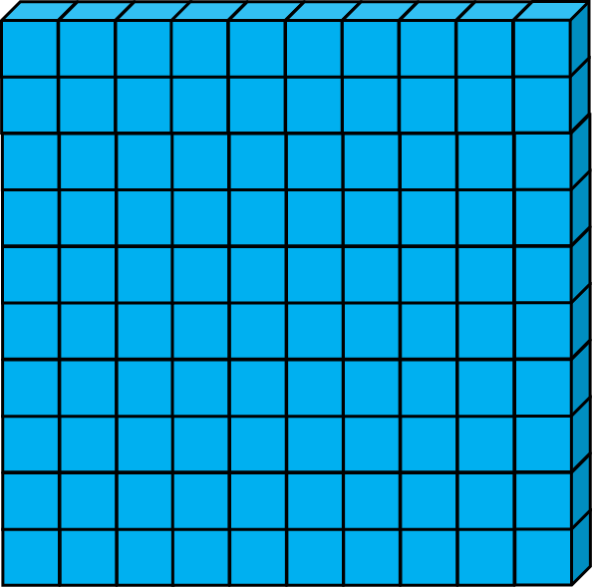





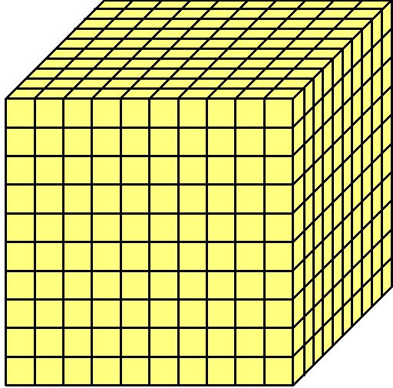

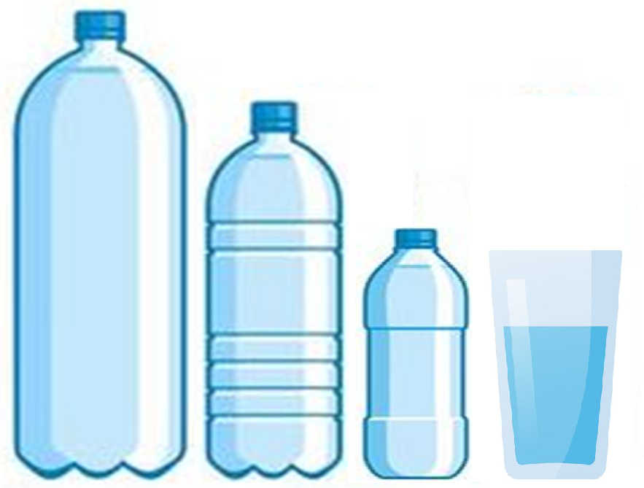

**السّعات**

**2L 1L**

**50CL 25CL**



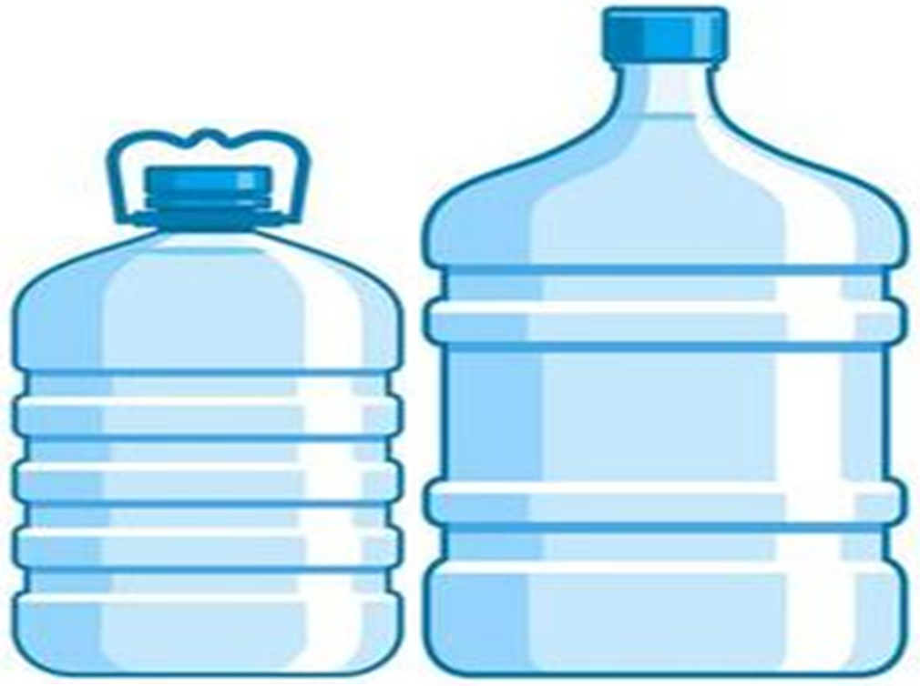

**5 L 10 L**





**مستقيمان متعامدان**



**مستقيمان متوازيان**



**الزّاوية القائمة**

**=**

**°90**



**الزّاوية الحادة**

**أقل من**

**°90**



**الزّاوية المنفرجة**

**أكبر من**

**°90**



**الزّاوية المستقيمة**

**=**

**°180**

